Raspberry Pi – interactive music instrument

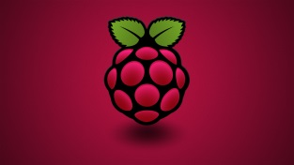

Welcome to the Raspberry Pi booth!

In this demo, you will perform a few simple tasks to make the device responsive to your hand gestures and play music.

1. Make sure that the raspberry pi is turned off and connect the sensor to the Raspberry Pi with the 4 connections wire (remember the numbers you have selected):

Gnd (green wire)-> Ground

Echo (blue wire) -> GPIO_xx

Trig (brown wire) -> GPIO_yy

Vcc (red wire) -> 5v

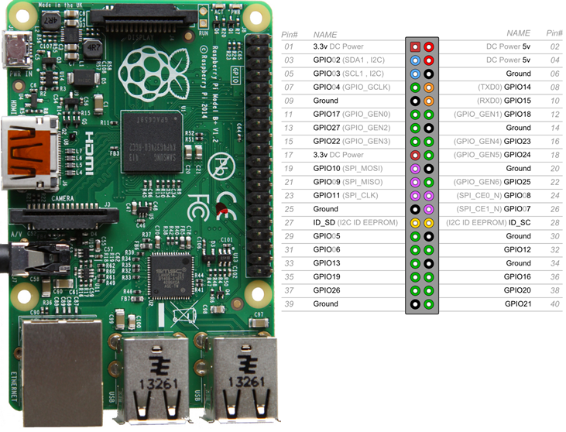

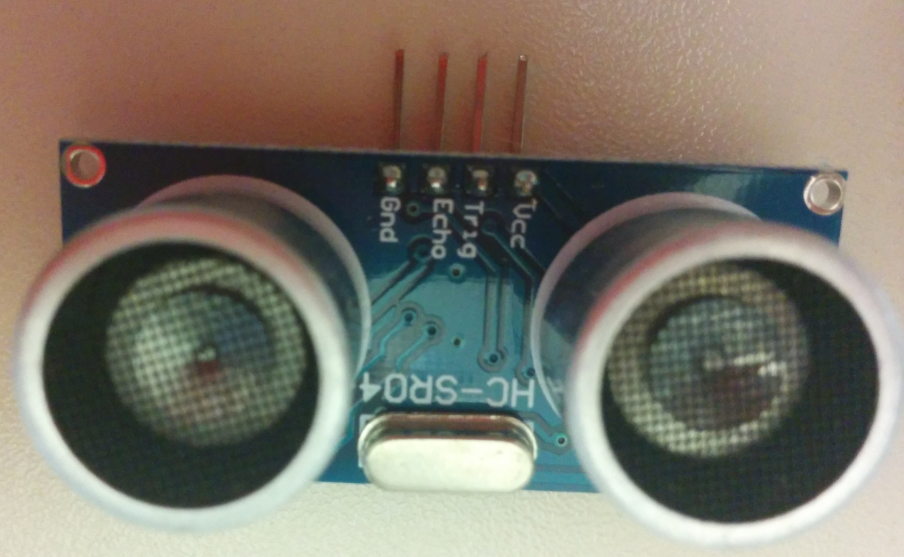

1. Connect the power wire to the RP (Raspberry PI).
2. Once your Raspberry Pi has completed the boot process, a login prompt will appear, login with User: pi password: admin
3. Type “cd SAP-dokm-handson/RP” and press enter.
4. Type “startx” in order to start up the desktop (this may take a few seconds).
5. Open file manager

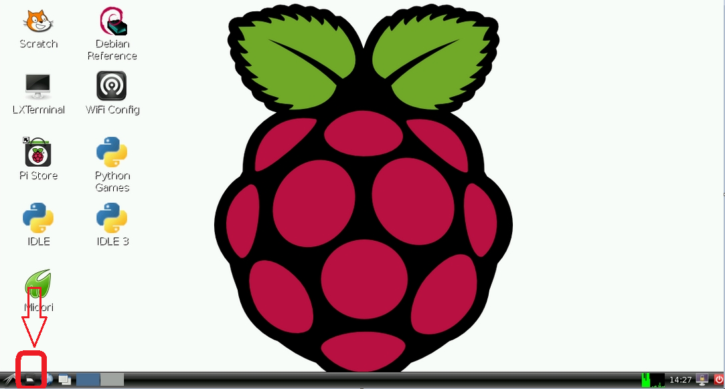

1. Open the file “exercise.py” for edit using IDLE (right click the file).
2. Set a value for GPIO_ECHO_BEEP and GPIO_TRIG_BEEP (one of the GPIO pins of the Raspberry pi) – **step 1 in the code.**
3. Set the desire distance threshold that should start the playing **(Step 2 in the code)**
4. Ctrl+s to save the file.
5. Run the code:
   1. Double click on “LXTerminal” located on the desktop.
   2. Write “sudo ./exercise.py” and press enter.
   3. Password: “admin”.
6. Once you hear the background music, put your hand above the distance sensor to start playing along.

